How to Use ParentVUE and StudentVUE

ParentVUE is a secure web-based information management system that provides parents/guardians the ability to view their child's schedule, assignments, grades, attendance, and contact information. The student version of the program is called StudentVUE. Families can also complete enrollment forms and verify student information through ParentVUE.

New Users: Create an Account
- Click the Login link on the ParentVUE page or open the mobile application.
- Click I am a parent
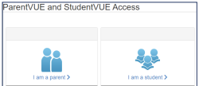
- Select More Options.
- Select Activate Account.
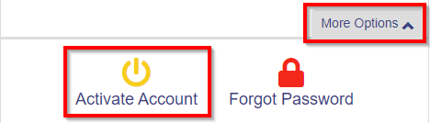
- Read the Privacy Statement and click I Accept.
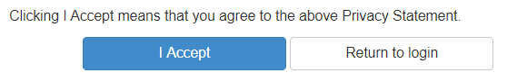
- Enter your name and activation key exactly as it appears in your letter from the school and click Continue to Step 3.
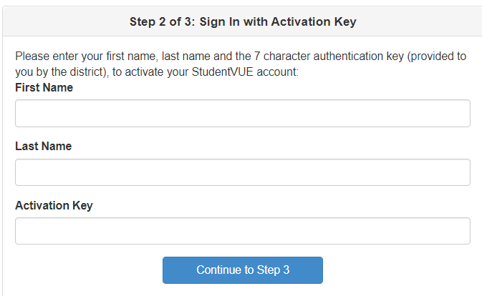
- Parents - Choose a user name.
Students enter your school email address for the User Name. Insert a secure password (minimum of 6 characters). Click Complete Account Activation.
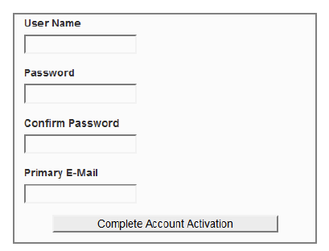
Existing Users: Log In
- Click the Login link on the ParentVUE page or open the mobile application.
- Click I am a parent
- Enter your user name and password and click Login.

Change or Forgot Password
- Click the Login link on the ParentVUE page or open the mobile application.
- Click I am a parent
- Select More Options.
- Select Forgot Password.
- Check email account for a link to change the password.

Re-enrolling a student
- After you are logged into ParentVUE, select
Online Student Enrollment & Update Student Information in the upper right-hand corner.
- Select New Student Enrollment
- Follow the self-guided process to complete enrollment.
- Contact the school once registration is submitted.

